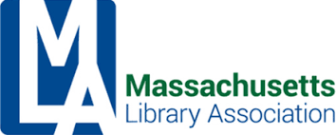

MLA Executive Committee Agenda
Friday, August 12, 2022, 10 – 12
Virtual Meeting via Zoom
Join Zoom Meeting https://us02web.zoom.us/j/82832523996
Meeting ID: 828 3252 3996

- Call to order
  - Vote to approve the minutes of the June 10, 2022 meeting
- President’s Report
- Treasurer’s Report (Bernadette)
- Association Manager’s Report (Rebecca)
- Conference Update (Conference Committee Co-Chairs)
- Committee Reports
- Update
  - MBLC
  - MLS
  - NELA
  - MSLA
  - Others
- New Business
  - MBLC and MLA: Media Requests Tips
  - LITS and Digital Privacy Issues
  - Website Update
- Old Business
- Adjournment
*Next meeting: Friday, October 14, 2022
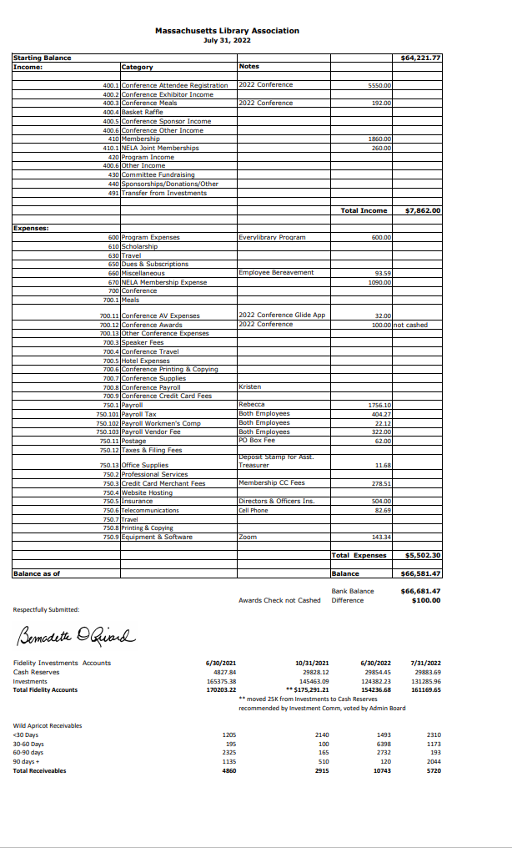

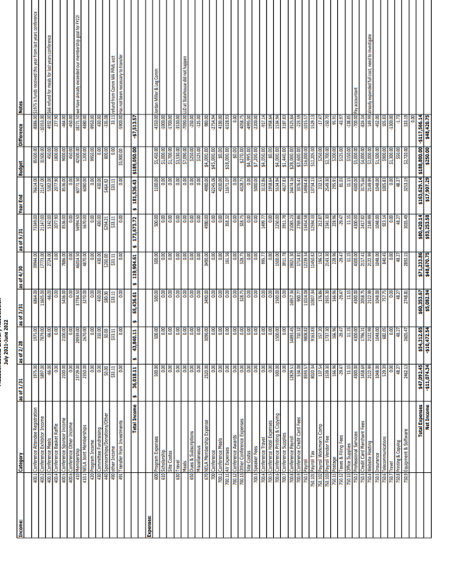

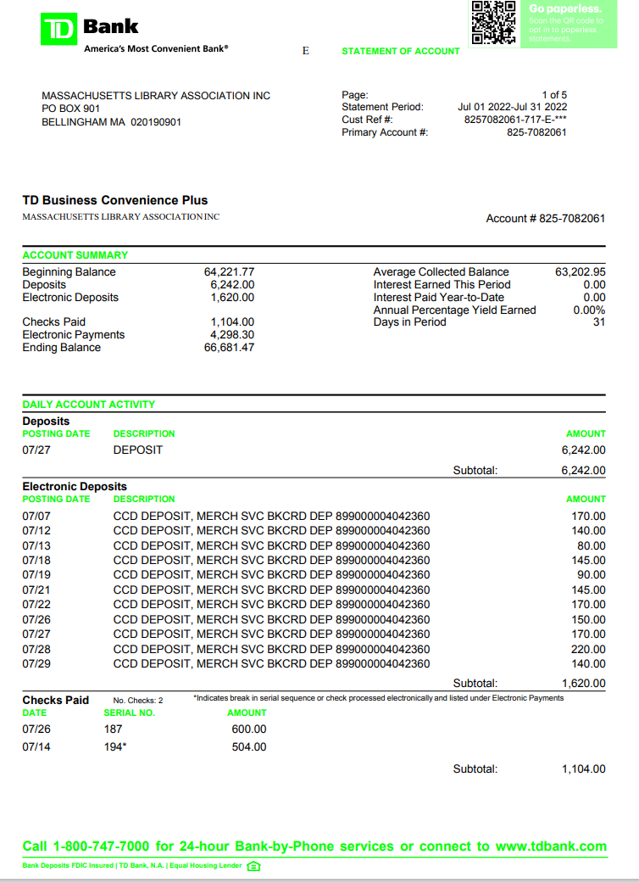

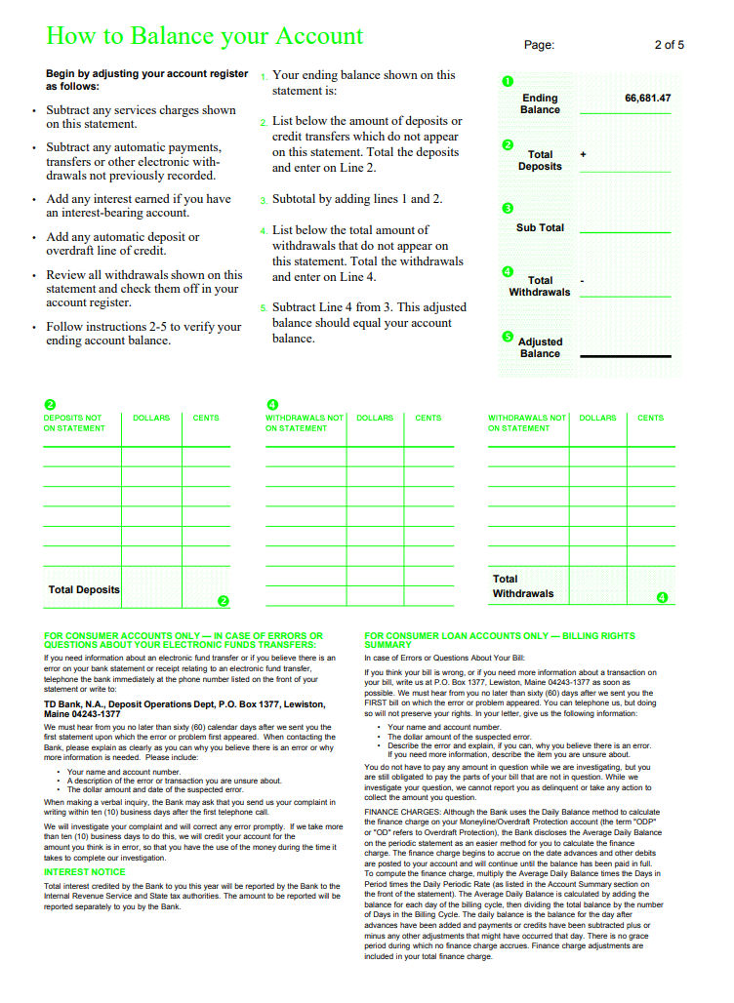

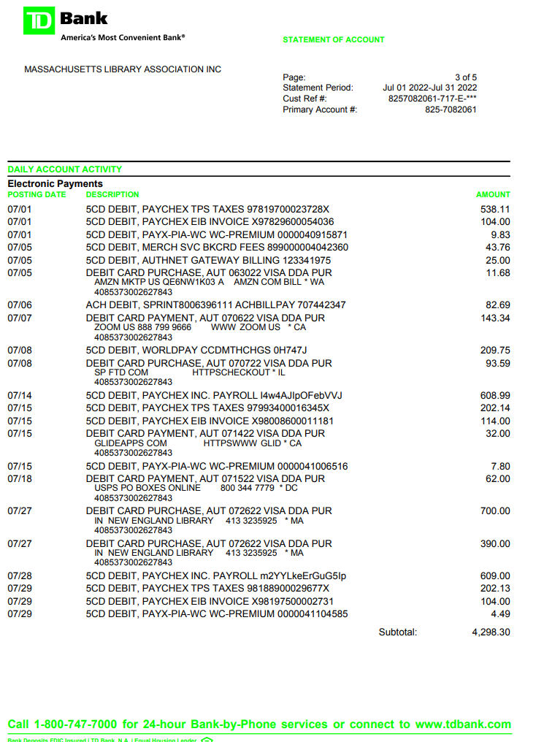

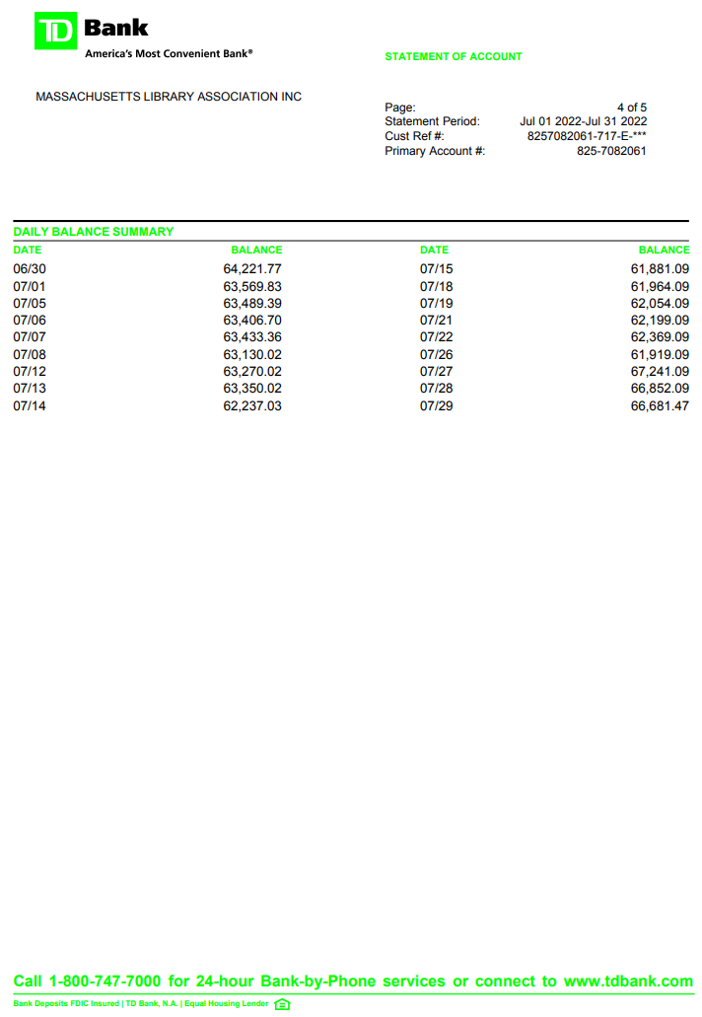

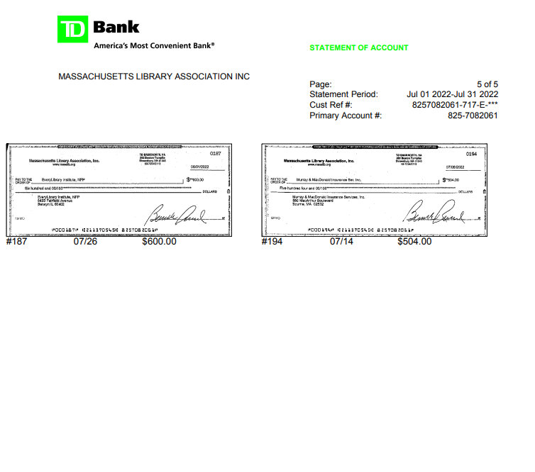

Invoices 60 days overdue
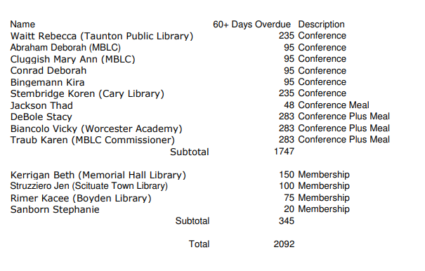

Library Information Technologies Section (LITS)
Executive Board Report — August 2022

MLA’s Library Information Technologies Section (LITS) continues to reboot. Following June’s transition meeting, LITS welcomed Andrea Puglisi as Chair of LITS. The short-term focus for this Section involved filling LITS’ Officers positions, and organizing upcoming objectives. To that end, LITS is pleased to welcome Jeremy Goldstein as “Member-at-Large”, and is grateful to Jeremy for volunteering to represent LITS’ voice on MLA’s Conference Committee. We believe that with Andrea’s and Jeremy’s contributions on MLA’s Conference Committee, LITS will fully fulfill its obligations to Conference this year. MLA LITS is also pleased to welcome Chris Kaufman as LITS “Member-at-Large”. We are working on establishing responsibilities unique to that role. Additionally, LITS is pleased to welcome Renee Pawlowski as LITS Secretary. MLA LITS is grateful to everyone who has volunteered to take on these additional roles in LITS.
Past Activities:
- June 15, 2022: LITS Chair sent to all of LITS Membership an Interest Survey to gauge interest level, commitment and to identify the best availability times to hold meetings. Response has been low, but we have plans to push out this survey again in order to ensure that MLA LITS is acting in interest with its Members.
- July 20, 2022: LITS held a meeting from 1:00 to 2:00 PM, with limited attendance. During this meeting, we discussed the results, Officer positions, possibilities to offer education on Digital Safety, and identified Bylaws as needing a revision.
- Next scheduled meeting is set for Thursday, September 15 at 2:00.
- LITS Chair has been working to establish a way to facilitate Section communications through Google groups, meeting a long-standing interest and need from Section members.
Upcoming and Ongoing Work:
- Continue to recruit Members and solicit feedback from Members via LITS Member Interest Survey that was sent out in June.
- Determine additional projects or resources to be generated by MLA LITS: ensure that this is Member driven.
- Explore the possibility of offering Digital Safety open forum conversations with LITS this Fall.
- Establish a By-Laws Committee to revise MLA LITS By-Laws.
- Work with MLA Conference Committee on identifying Speakers on topics related to LITS for 2023 Conference.

Respectfully submitted,

Andrea Puglisi, LITS Chair
August 18, 2022

MLA Legislative Report
August 2022

The Legislative Committee held our most recent meeting (hybrid) on June 17, 2022 at the MLS meeting room, where we bid farewell to Jennifer Harris as Co-chair of the Committee, and enjoyed a feast of pizza, salad, and ice cream, generously provided by Jennifer. We thanked Jennifer for her leadership and her role in the Legislative Committee’s achievements during her tenure. Eileen Dyer of Swansea Free Public Library has been named Co-chair of the committee to serve with current co-chair Will Adamczyk.
Summer: The Legislative Committee is on hiatus for the summer and will meet again on September 23, 2022.
Legislative Update – State Budget:
On July 28, Gov. Baker signed the FY23 Budget with no vetoes/adjustments to any library lines from the legislature's Budget Conference Committee. Included in the bill is increased funding to library line items at or above what was requested in the FY23 Legislative Agenda!
From MBLC website:
Line Item Number and Name | FY 2021 | FY 2022 Budget | FY 2023 Legislative Agenda | FY 2023 Increase Over FY 2022
7000-9101Board of Library Commissioners | $1,579,876 | $1,702,272* | $1,708,636 | $81,364
7000-9401State Aid to Regional Libraries | $12,516,000 | $13,516,000 | $14,516,000 | $1,000,000
7000-9402Talking Book Library | $482,264 | $496,732 | $521,569 | $24,837
7000-9406Talking Book & Machine Lending | $2,745,774 | $2,828,147 | $2,969,554 | $141,407
7000-9501State Aid to Public Libraries | $12,000,000 | $13,000,000 | $16,000,000 | $3,000,000
7000-9506Library Technology & Resource Sharing | $4,386,770 | $4,518,373 | $4,744,293 | $225,920
7000-9508MA Center for the Book, Inc | $225,000 | $300,000 | $400,000 | $100,000
Totals | $33,935,684 | $36,361,524 | $40,860,052 | $4,573,528

Upcoming Legislative Session preliminary priorities:
- Continue work with Rep. Ruth Balser, representatives from Library Futures, EveryLibrary, and others on Massachusetts eBook bill
- Support MBLC Legislative Agenda via advocacy for statewide Library Budget
- Library Legislative Day: In-person & Virtual days
- Track relevant non-budgetary legislation throughout the term; Advocate for appropriate legislation
- Continue to build national and statewide alliances with organizations supporting similar or parallel mission or values as libraries; support relevant legislation in appropriate fashion
- Investigate introducing new state legislation regarding the protection of library workers in this new era of censorship, as well as other potential library legislative efforts

Respectfully submitted,
Will Adamczyk
Eileen Dyer

MLA Legislative Committee Co-chairs

MBLC Director’s Report to MLA Executive Board
August 2022

Governor Baker signed the FY2023 operating budget on July 28 and didn’t veto/adjust any of the proposed amounts for our line items from the Conference Committee. Our State Aid to Public Libraries line received $16 million, a 23% increase over the FY2022 funding level, and an increase of just over 59% since FY2020. State Aid to Regional Libraries received a $1 million increase for the third year in a row (in addition to a larger increase of $1.2 million in FY2020). The Mass. Center for the Book’s budget of $400,000 is now double its FY2020 funding level, however the Center was level-funded from FY2016 until FY2020.

ITEM NO. | ITEM NAME | FY 2022 BUDGET | FY 2023 LEGISLATIVE  AGENDA REQUEST | FY 2023 FINAL BUDGET
7000-9101 | Board of Library Commissioners | $1,702,272* | $1,708,636 | $1,731,586
7000-9401 | State Aid to Regional Libraries | $13,516,000 | $14,516,000 | $14,516,000
7000-9402 | Talking Book Library (Worcester) | $496,732 | $521,569 | $521,569
7000-9406 | Talking Book & Machine Lending (Perkins) | $2,828,147 | $2,969,554 | $2,969,554
7000-9501 | State Aid to Public Libraries | $13,000,000 | $16,000,000 | $16,000,000
7000-9506 | Library Technology & Resource Sharing | $4,518,373 | $4,744,293 | $4,744,293
7000-9508 | Center for the Book | $300,000 | $400,000 | $400,000
TOTAL: |  | $36,361,524 | $40,860,052 | $40,883,002

On the capital side, our annual cap for the MPLCP is now $24 million for FY2023.
Tracey Dimant, Mary Rose Quinn, Lauren Stara, Andrea Bono-Bunker and I met virtually with Timur Yontar, Assistant Capital Budget Director, Executive Office of Administration & Finance (A&F) on July 14 to discuss how to get on the “to do” list that A&F will leave for the next Governor for a new bond authorization for our next MPLCP grant round. We tentatively plan to announce the grant round later this fiscal year, with applications due in FY2024 and awards made in FY2025. Timur is investigating the possibility of our making awards tied to a general A&F capital bond if our new construction bond has not been approved in time for making awards in July 2024 (it can take two legislative years to get a bond bill passed).
Celeste Bruno, Matt Perry, and I met with Sharon Shaloo and Mass. Center for the Book colleagues on July 27 to discuss the possibility of the MBLC co-sponsoring a “Commonwealth Conversation” with MCB for a second year this fall, with a “Books in Action” focus on climate change. We have invited Michelle Eberle from MLS to consider joining the planning team for this event, given the excellent work she has been doing in this area.

We will also be co-staffing the Massachusetts booth with the MCB at the upcoming National Book Festival in Washington, DC on Labor Day weekend. Matt Perry will be representing the MBLC at the event.

The Team held two “Tips for Working with Media” zoom sessions attended by 80 people in which they discussed the basics of handling media interactions and answered questions from the participants.
The Team has held five summer reading events so far this year. The kickoff at Medford Public Library was attended by 12 Bruins prospect players and was led by Rachel Masse and Matt Perry. At the Tyngsboro Public Library, First Lady Lauren Baker was in attendance as was Olympic Gold Medalist and Boston Pride President Colleen Coyle, State Representative Colleen Garry, and Bruins mascot Blades. Ms. Coyne brought the Isobel cup and was a huge hit answering questions and letting kids hold her gold medal. Commissioner Cluggish led the event off with a welcome to the crowd of about 80 people and recognized VIPs including the town administrator and library trustees.
In Ipswich, they were joined by Pride Player Kali Flanagan who also brought the Isobel Cup. Kali is an Olympic Gold Medalist as well and shared her medal from the 2018 South Korea Olympics with the crowd of 350 people. Commissioner Vilas Novas greeted families and handed out READ posters and drew the trivia prize winners in a random drawing. Bruins mascot Blades posed for pictures and had fun with the children. In Grafton, families enjoyed story time with Blades, trivia with Commissioner Traub, and fun activities and games. Matt Perry ran the Sterling event during the library’s picnic/concert with Blades posing for photos and crafts for kids. Three events remain: Wilmington, Wareham, and Hamilton-Wenham.
Regarding book/material challenges, Maura Deedy has been regularly focusing on intellectual freedom and how to prepare for material challenges (including the requirement for public libraries in the Commonwealth to have a collection development policy) in her work with library trustees and directors, whether through all-regions emails, her Trustee Deep Dives, or forwarding information about ALA and/or United for Libraries efforts in these areas (including several recent webinars), as well as our own Collection Development and Intellectual Freedom LibGuide (https://guides.mblc.state.ma.us/c.php?g=43533&p=8978900). In addition, both Rob Favini and Maura regularly provide guidance/advice about these issues in their frequent advisory sessions. They are also in regular communication with the MLA Intellectual Freedom/Social Responsibility Committee and MLS to keep up to date on challenges and to offer guidance. Finally, Mary Rose Quinn and State Aid unit staff field questions and provide guidance related to material challenges and State Aid to Public Libraries program requirements.

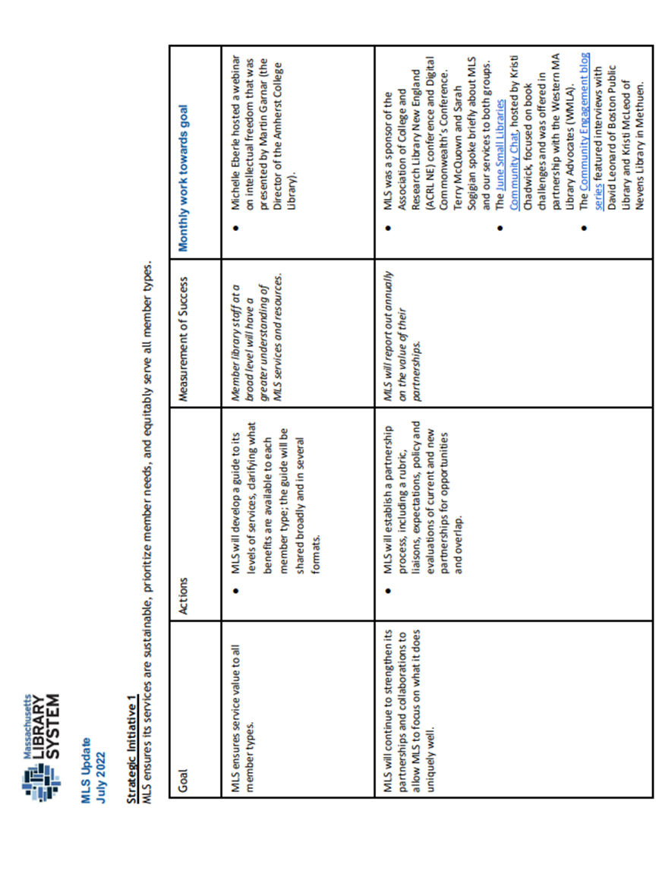
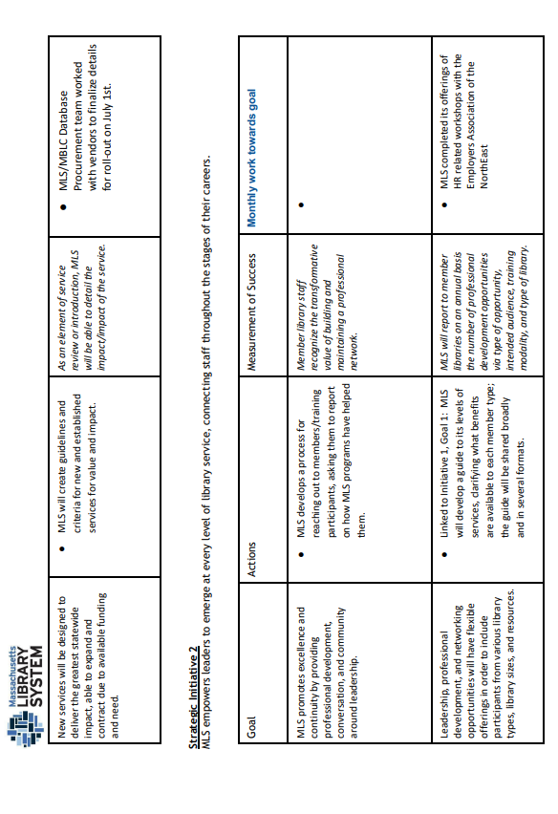
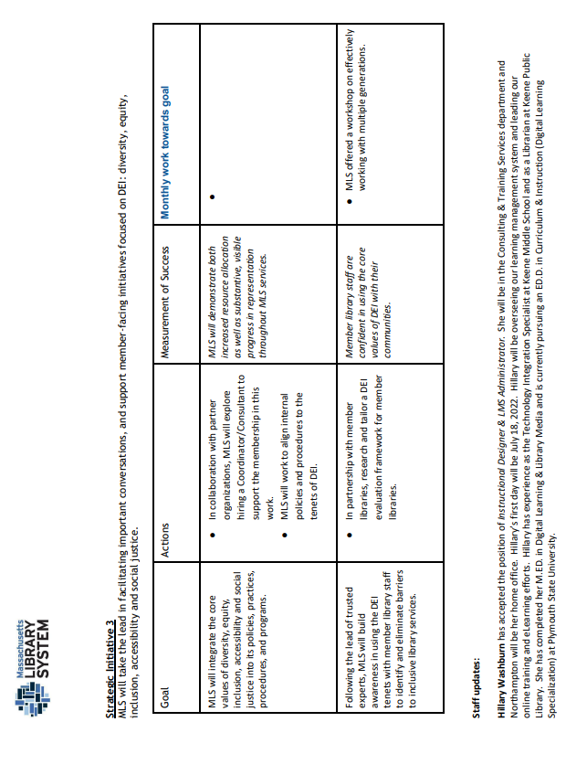

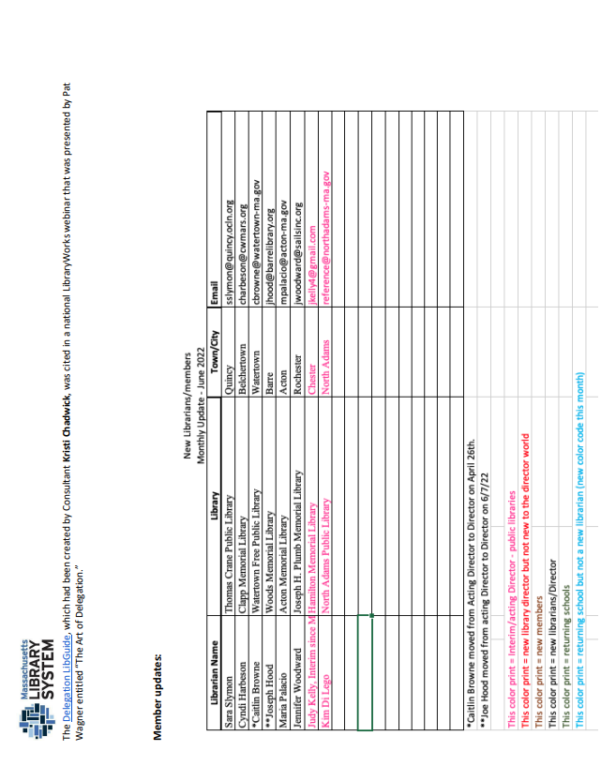

Personnel & Education Committee Report August 2022

Committee Update:
The Committee has come back together with a great group, beginning meetings in July. We will be meeting virtually every month on the second Tuesday from 10-11am. All are welcome! Please let us know if you have any recommendations for new Committee members. We are eager to grow the group. Our mission can only be improved by the addition of individuals with varying backgrounds.
Mission Statement:
To recruit, inform, and support library workers and advocate for library staff by helping to create a diverse, equitable environment for all.
Committee Members:
Saffana Anwar, Assistant Manager of Borrower Services, Cambridge Public Library
Noelle Boc, Director, Peabody Institute Library of Danvers, Co-Chair
Hermayne Gordon, Director, Woburn Public Library
Kelly Linehan, Director, Waltham Public Library
Meg McConnell, Assistant Head of Access Services, Peabody Institute Library of Danvers
Janina Mueller, Metadata and Digital Initiatives Librarian / Assistant Professor, MA College of Pharmacy and Health Sciences
Emelia Thibeault, Officer Supervisor, Goodnow Library, Co-Chair
Kate Tigue, Head of Youth Services / Lead Union Rep., Morrill Memorial Librarian
Heath Umbreit, Adult Services Librarian, Morrill Memorial Librarian
Miki Wolfe, Director, Morse Institute Library
Next Steps:
Developing a strategic plan and accomplishable goals.
Current Topics of Discussion:
- Professional and financial support for underrepresented groups
- Training, educational opportunities, mentorship
- Collaboration with other MLA Committees and outside organizations (MBLC, MLS, MLN, etc.)
Respectfully Submitted,
Noelle Boc & Emelia Thibeault, Personnel & Education Co-Chairs

