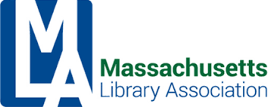
Administrative Committee Meeting
Minutes

November 18, 2022 at 2pm
Meeting via Zoom

Attending: Kim Hewitt (President), Joanne Lamothe (Past President), Bernadette Rivard (Treasurer), Tina McAndrew (Secretary), Kristen Collins, Sarah Breen, Michelle Filleul

Call to Order at 10:04am

Motion made to accept the minutes of the September 9, 2022 meeting made by Bernadette Rivard and seconded by Michelle Filleul.

Treasurer’s Report - Bernadette Rivard
a. Taxes Owed/Paychex
Bernadette shared her response to Paychex regarding the past due amount and is still working toward a solution with them.

Association Manager Report
Kim introduced Kristen as taking over the role of Association Manager as well as maintaining her role as Conference Director. The Administrative Committee will work toward permanently combining these roles. Kristen shared some of the updates she is working on to streamline the processes of both positions into one.

Highlighting Non-MLA Groups/Page for partners on website?
After discussion among the Committee members, it was agreed that the MLA page is not the right venue to host such pages. Perhaps in the future with an updated website partnering with non-MLA groups will be a possibility.

Continuing Ed Grant
Members discussed contributing monies toward the grant and for Massachusetts members to attend the NELA conference. More to be considered next month at the Executive Committee meeting

Other Business
a. NELA/NELLS
b. MLS Continuing Ed Grant

Adjourn at 10:42am

Respectfully Submitted,

Tina McAndrew
MLA Secretary

