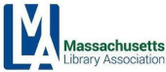

Meeting Name | Executive Board Meeting  Transition Meeting
Meeting Date, Time + Location | Friday, June 9, 2023 | 10:00 am - 12:00 pm  Virtual Meeting via Zoom  Meeting ID: 828 3252 3996
Agenda at-a-glance | 10:00 - 10:30 am | Business Meeting  10:30 am - 12:00 pm | Transition Meeting

BUSINESS MEETING

Call to Order
Approve minutes from April 10, 2023 E-Board Meeting | All

Treasurer’s Report | Bernadette Rivard

2023 Conference Report | Conference Committee Chairs

Partner Organization Updates | Organization Representatives
- MBLC
- MLS
- MSLA
- NELA
- Mass Center for the Book

Save the Date: E-Board Meetings | Eventkeeper

Executive Board Meeting Adjourns

TRANSITION MEETING + SECTION CHAIR TRAINING

Introductory Remarks and Agenda Review | Kim Hewitt and Michelle Filleul

Incoming Officers Introduction | Roles and Duties | Kim and Michelle
- President
- VP/President Elect
- Past President
- Treasurer
- Assistant Treasurer
- Secretary

MLA Budget and Timelines | Sarah Breen
Important timelines
- Submit budget | October
- Discuss and finalize | December
- Vote on budget | February

Introduction of MLA Staff and Explanation of Roles/Responsibilities | Kim and Michelle

- Interim Association Manager and Conference Director, Kristen Collins
Important Documents | Kim, Michelle, Kristen

Info Sheet for Committee Chairs
Overview of Google Drive and MLA website
Social Media Policies and Guidelines (see Info Sheet linked above)
By-Laws and Strategic Plan
Section Mission Statements
Budget
Calendar Eventkeeper | Annual Calendar
Contact List for Organization

Committees, Sections, Liaisons + Archivist Expectations | Kim and Michelle

Participation
- Attend Executive Board meetings (one vote per section)
- Hold regular section meetings/programs and post on Eventkeeper
- Develop and propose programs for Annual Conference
- Appoint a liaison for Conference Committee and ensure that person attends Conference Committee meetings
- Appoint a liaison for Public Relations Committee and ensure that person attends PR Committee meetings

Finance and Reporting
- Create and submit a budget by October deadline
- Prepare reports for E-Board meetings (6 times a year)
- Prepare an annual report for Annual Business Meeting (held at Conference in May)

Administrative
- Update the E-Board Contact List with the most current list of members/contact information
- Maintain accurate information on Masslib.org
  - Regularly review your area of the website
  - Supply association manager with information for posting
Introduction of Committees, Sections, Liaisons + Archivist | Kim and Michelle

- Conference Committee
- IFSRC
- Jordan Miller
- Legislative
- LITS
- Membership
- Paralibrarian
- Personnel
- PR
- Programming
- YSS
- Archivist
- ALA Councillor

Transition Meeting Adjourns

MBLC Director’s Report to MLA Executive Board
June 2023

FY2024 Budget: The Massachusetts Senate voted on the FY2024 budget on May 25. The Senate budget funds six of our seven budget lines at the amount requested in the MBLC’s FY 2024 Legislative Agenda. The Mass. Center for the Book received level funding and an amendment from (now former) Sen. Gobi to increase that line by 10% failed. Senator Jake Oliveira sponsored an amendment for the State Aid to Regional Libraries line for $750,000 and used the opportunity of his inaugural address to his colleagues in the Senate to promote his support for libraries in his district and across the Commonwealth. His complete address can be found at https://mblc-newsroom-static.s3.amazonaws.com/collateral/official-docs/mblc/371e26a3_senator-oliveiras-inaugural-speech_download.pdf . This amendment added funds to the Ways & Means proposal, already at the Legislative Agenda requested amount, to increase the final total for 7000-9401 to $16,717,600. For the FY2024 budget progress to date, please see: https://mblc.state.ma.us/about-us/budgets-and-funding.php
While nothing is official yet and the numbers are still preliminary, we have been told that the Executive Office of Administration and Finance (A&F) is still planning to increase the MPLCP cap from $24 to $25 million for FY2024. Regarding our request for a new bond authorization, the Healey/Driscoll administration plans to file new bond bills this summer and will include the MBLC’s $150 million request in the mix.
On June 1, the Commissioners voted to approve one-time additional escalation grant payments totaling up to $10,623,037 to the municipalities of Amherst, Deerfield, Fitchburg, Gloucester, Littleton, Lynnfield, Marlborough, Melrose, Sharon, Swansea, and Westford for their projects in our 2016-2017 Mass. Public Library Construction Program grant round.

MLA 2023 Annual Conference Update: In addition to the very successful MBLC booth in the Exhibit Hall, Shelley Quezada teamed up with MLS’s Michelle Eberle to moderate the panel discussion: Library Social Work: Micro, Mezzo, and Macro Roles. The panel included Marie Mathieu, Library Social Worker, Cambridge Public Library; Taylor Morris, Library Social Worker, Boston Public Library; Emma Henson, Social Work Intern, Cambridge Public Library; and Isabella Burtscher, Social Work Intern, Boston Public Library. Lauren Stara presented a session titled Healthy and Inclusive Library Buildings. I presented the State of the State/MBLC Update during the annual MLA Business Meeting.

E-Rate Consultant Kickoff: On May 11th Paul Kissman and Rob Favini met with EdTech Strategies’ Aleck Johnson to kick off the beginning of a two-year E-Rate consultant services engagement. With this engagement we hope to increase the participation of Massachusetts libraries in obtaining federal funding for broadband and connectivity services. EdTech will spend the first year gathering information, educating libraries, and working with key stakeholders like the state’s automated networks. Year two will focus on helping libraries with the application process.

LSTA Direct Grant Round Update – SACL Review: On May 16th State Advisory Council for Libraries (SACL) members gathered in person to review the FY2024 LSTA Direct Grant Applications. SACL members were divided into sub-groups where they discussed and shared scoring of final applications. Direct Grant recommendations will be presented to the Commissioners for approval at the July 2023 Board Meeting. Many thanks to SACL members for attending and to the LAD team: Lyndsay Forbes, Shelley Quezada, Amy Clayton, Kate Butler and Evan Knight for meeting planning and leading group discussions.

Mass Broadband & Digital Equity Working Group: The MBLC continues to represent the voice of libraries with the Mass Broadband & Digital Equity Working Group. This statewide group is a coalition of state agencies, non-profits, local and regional economic development organizations, broadband providers, housing agencies, and social work organizations. I attended the May 3 meeting in Westborough in-person while Paul Kissman and Rob Favini attended virtually. This meeting featured presentations on the Federal Funding Landscape and Statewide Planning – Stakeholder Engagement.

Lyndsay Forbes will lead Massachusetts in the IMLS-funded project Building Equity-Based Summers (BEBS) taking part in the year 2 cohort. BEBS is a national initiative focused on assisting public library staff in gaining the skills necessary to work with systematically marginalized communities. The project, started in California in 2020, received funding from the Institute of Museum and Library Services in 2022 to expand their work across the United States. As library summer services are universal across the United States, summer is the perfect opportunity to build equitable practices. Summer can therefore act as a jumping off point for laying a foundation of equity in all library services.

Lyndsay will participate in 8 learning sessions this summer. This fall she will recruit five public library teams who will participate in learning sessions facilitated by Massachusetts trainers. Learning sessions will cover the why of summer; letting go of tradition; connecting with community voices; and measuring impact and success. The project will also involve a monthly community of practice and iteration of related support materials. Christi Farrar from MLS is also participating in a support role for the program.

Maura Deedy presented the United for Libraries webinar Strategic Planning: What Your Library Board Needs to Know with Stephanie Chase, founding principle of Constructive Disruption, Public Library Association Board Member, and incoming ALA Executive Board member. Targeted to libraries in the process of creating a strategic plan, or those in need to get their library’s trustees on board with a current plan, knowing if it’s time to have a strategic plan, or to redo the one they have. Maura and Stephanie presented an overview of the strategic planning process, the board’s role, how to know if and when you should hire a consultant, and more. A recording is available https://elearning.ala.org/course/view.php?id=1036&pageid=4207 on the Massachusetts state-wide United for Libraries page.

Maura has also been invited to serve a 2-year term on ALA’s Committee on Advocacy begin on July 1, 2023. The Committee on Advocacy charge is: To support the efforts of advocates for all types of libraries; to develop resources, networks and training materials for advocates at the local, state and national levels with particular emphasis on the grassroots level; to work closely with the office for library advocacy in collaboration with the public awareness committee, the chapter relations committee, the committee on legislation, and other ALA offices, divisions, and round tables as well as external groups to integrate advocacy efforts into the overall planning, priorities and policies of the association; and to cultivate future leadership in order to sustain and enhance the advocacy efforts of the association.

On May 12th Shelley Quezada and MLS’s Michelle Eberle convened a virtual Ask a Mental Health Advocate session. The event allowed library staff to chat with statewide mental health advocates. Attendees learned about resources available and received guidance on how to handle situations that come up at the library related to mental health. The mental health advocates represented a wide variety of state and local agencies and organizations:
Daniela Harrigan, Director of Community Engagement, Mass.DMH
Jessica Larochelle, Co-Director of Policy & Gov’t Relations for the Mass Assoc. for
Mental Health
Jill Gichuci, COMPASS Helpline Director, NAMI Massachusetts
Joe Vallely, Housing Specialist, Mass DMH
Marie Mathieu, Cambridge Public Library, Social Worker
Mio Tamanaha, Director of Behavioral Health Help Line, DMH
Yuka Gordon, Metro Boston Recovery Learning Community

The Communications Team coordinated the MBLC booth at the MLA conference. This year the focus was on MBLC materials librarians could take and begin using right away in their libraries. Nearly 3,000 new database bookmarks for kids, teens, and adults were distributed. Statewide ordering for these will be offered once the summer orders are processed. Bruins materials which feature the consumer portal (libraries.state.ma.us) included posters and bookmarks. Thousands were distributed. Financial Literacy bookmarks, activity booklets, and calendars which were developed with our partners from the Office of Economic Empowerment, were also given out.

Given the large number of new directors, the booth featured State Aid information, the Trustee Handbook, and MBLC at a Glance which gives brief descriptions of MBLC services and contact information. Information on the construction bond and the new construction map were also available. For fun and to help lessen the confusion between MBLC and MLS, the team created an interactive game to help participants understand what the MBLC does and what MLS does. Those who answered correctly were entered into a drawing for a Bruins jersey and Blades summer visits. Rachel Masse and June Thammasnong also answered questions and were ideal MBLC representatives.

OCLN is the latest Network to join the library road trip, originally started with the SAILS network to encourage resource sharing. The communication team and Buyer worked with OCLN to adapt the website and materials for the OCLN’s road trip which starts in June. The team also met with interested folks from NOBLE.

The new “You belong here” video is in final edits. Developed with the statewide Public Relations Committee, the goal of the video is twofold: it will be used to promote the newly designed portal and it will be used to communicate that everyone is welcome in libraries.
Summer digital ads in Spanish as well as English began running mid-May and will continue until mid-June. The ads feature artwork for the statewide program through iRead and lead users to the consumer portal where they can find more information and locate their local program.

Ordering of Bruins summer materials wrapped up with libraries ordering nearly 15,000 items. The following libraries will have Blades summer visits: Sandwich, Scituate, Hudson, Haverhill, Colrain and Ashland. The Bruins are currently working with libraries to confirm dates.
On June 1, the Commissioners voted to approve the joint MLS/MLA/MSLA/MBLC statement titled “Massachusetts Library Organizations Stand with Librarians Against Censorship and Intolerance”: https://mblc.state.ma.us/news/news-releases/2023/nr230601.php
Please visit: https://mblc.state.ma.us/censorship-freedom/index.php for our (still under-development) webpage on Censorship and Intellectual Freedom.

Interim Association Manager Monthly Activity Report
Name: Kristen Collins
Date: June, 2023
Member Relations | - Managed incoming emails/inquiries/phone calls (most calls were spam)  - Fixed some people’s memberships  - Archived a number of contacts  - Attended MLA Conference
Technical | - Updated MLA Conference Website  - Cleaned up and archived hundreds of old contacts
External Relations | - Prepared NELA report and sent to NELA rep  - Created new members via ALA  - Forwarded and responded to numerous media inquiries
Conference Management | - Managed attendee, exhibitor and sponsor event registration  - Final details for conference  - Set up site inspection w AV provider  - Closed BonFire Campaign  - Attended conference committee meetings  - Sourced and signed off on 2024 program  - Finalized menus, specs for event  - Run of show meeting
Finance | - Forwarded invoices for conference for payment  - Reviewing final bill as of 6/6/23
Next steps | Conference:  - Send info to graphic designer for 2024 branding  - Open exhibitor and sponsorship registration sooner  - Source 2025 program  Association Management:  Assess priorities:  - Meet with NELA manager about streamlining reporting

MLA Conference Committee Info Sheet

Conference Co-Chairs: Ellen MJ Keane (Co-Chair, UMass Lowell), Joanne Lamothe (Co-Chair, Sandwich); Esme Green (Co-Chair, Sudbury); Laurie Lessner (Co-Chair, SAILS)
Conference Director: Kristen Collins

2023-24 Conference Committee

Next year’s conference will be held on May 6-7, 2024 at the Sheraton Framingham Hotel and Conference Center

The mission of the Conference Committee is to promote professional development within the Massachusetts library community through the planning and execution of a high quality annual conference. We aim to present a conference which features a robust mix of local and nationally recognized leaders, innovators and speakers who will engage with a wide range of relevant topics that will encourage thought, conversation, action, and growth among individuals in all library roles and in all library types. We strive to recruit and highlight speakers on topics that are on-trend in the library field, and to create opportunities to connect and build networks with others in the field.
What do we do?
- Develop conference branding
- Solicit, submit and develop program proposals
- Identify, recruit and coordinate with speakers
- Craft the conference slate of programs
- Write and edit program descriptions for conference program and mobile app
- Work with MLA PR committee to promote conference and conference events
- Develop social evening events like Trivia, Karaoke
- Run Special Events such as Basket Raffle and Kay Bader Scholarship
- Awards: Hall of Fame, PR Awards, Para-librarian Awards
- Liaise with vendor for Conference App
- Identify potential Sponsors and Exhibitors in collaboration with Conference Director
- On-site conference tasks

Conference Committee Meetings (normally 3rd Friday of each month) 10 am-12 pm [usually virtual]:

- July 21
- Aug 18
- Sept 15
- Oct 20 - in person
- Nov 17
- Dec 15 - co-chairs only
- Jan 19
- Feb 16
- March 15
- April 19
- Shepherd training TBD
- May 6-7 conference

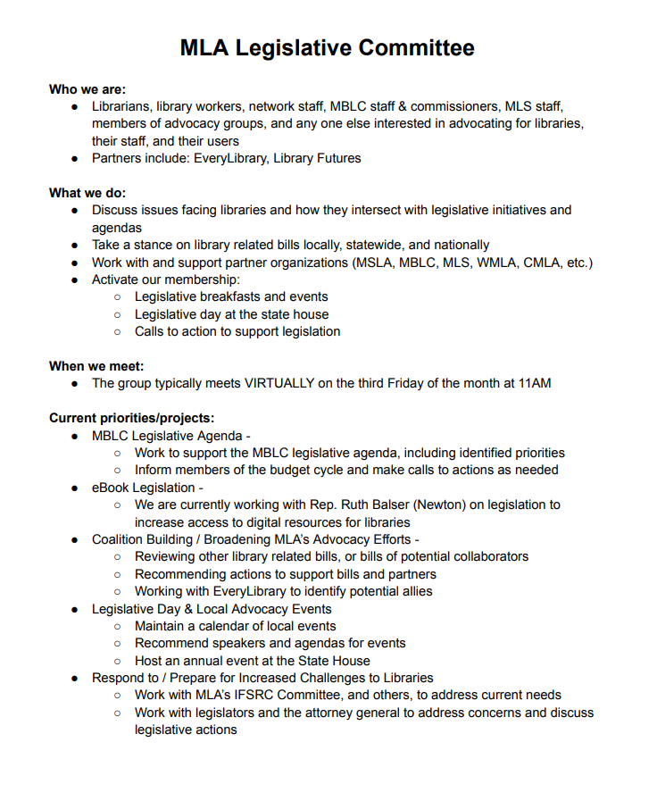

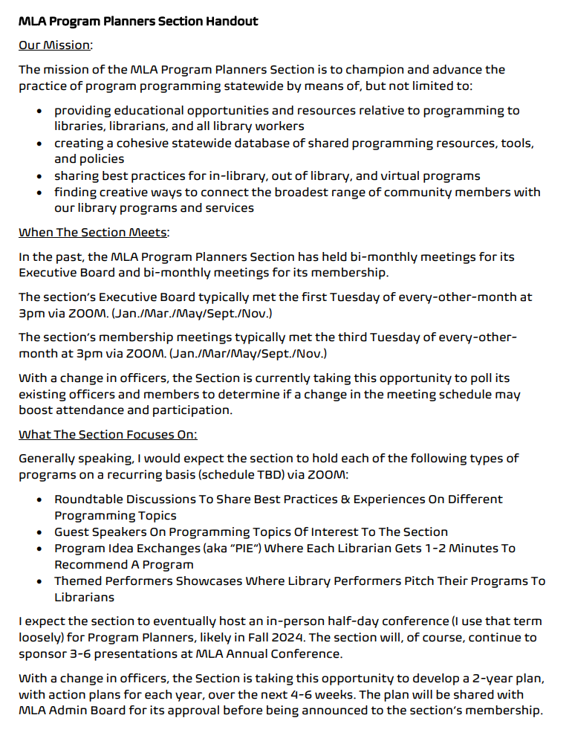

Personnel Issues and Education Committee (PIE) Summary

Mission: The MLA Personnel Issues and Education Committee will establish themselves within the Massachusetts library community as a resource regarding continuing education for all staff on personnel topics.

Action Plan: The committee will work to remove barriers to entry into the field of librarianship and to continuing education. Barriers include: cost, degree requirements, lack of diversity, systemic racism, and lack of competitive salaries and benefits. This committee will maintain transparency and integrity around all topics.

- Work to remove barriers to entry into the field
  - Work with MLIS programs
    - Introduce a scholarship program for MLIS students. (investigate MBLC funding; MLA funding)
  - Promote existing training and certification programs provided by MLS, MLA, and other organizations
  - Provide best practices for libraries on hiring, DEI, and related topics
  - Provide samples of interview questions, job descriptions, and job postings (exemplar of process from start to finish)
  - Provide social and financial resources for staff interested in progressing in their careers
  - Increase diversity within the field of librarianship by expanding outreach and recruitment efforts to underrepresented groups
    - Introduce a paid internship for high school students.
- Support libraries in their retention of staff
  - Define a leader in any position
  - Advocate for re-evaluation of existing professional hierarchies
  - Promote the state salary study and recommended standards
  - Provide professional support for underrepresented groups in the library field
  - Provide inclusive opportunities for career advancement within the field of librarianship
  - Connect staff with existing professional organizations for support and training

PIE meets every other month, currently on the 2nd Monday at 2pm.

We focus on working on different aspects of the Action Plan during our meetings.

CONFERENCE COMMITTEE
MLA Executive Board Report
June 9, 2023 (transition meeting)

The MLA 2023 Conference: Making Waves was held at the Sea Crest Beach Hotel on May 8-9, 2023

Highlights of programming: We received a lot of positive feedback from attendees about the content of not only the general sessions but also the breakout sessions. Attendees enjoyed the presentations by:
- Jonathan Friedman Director, Free Expression and Education Programs, PEN America, “The Evolving Movement to Ban Books and Censor Education”
- Tommi Laitio, Bloomberg Public Innovation Fellow, Bloomberg Center for Public Innovation at Johns Hopkins, "Learning Grounds for Conviviality" (wonderful research on libraries as public spaces and democracy-builders)
- American Library President, Lessa Kananiʻopua Pelayo-Lozada, who gave an update on the work of ALA, the increased number of reported book challenges, and resources ALA offers in support
- Ruth Balser, State Representative from Newton, and Steve Potash, CEO of Overdrive, discussed the state of pricing and availability of ebooks in libraries
Final expenses/income: TBD
Total attendance: 449 (475 last year)
Exhibitors: 42 exhibitors (37 last year)
Sponsorships: 12 (18 last year)
- 3 platinum
- 4 gold
- 5 standalone ads

Kay Bader scholarship winners:
- Kristen Barenthaler
- Kamryn Barrows
- Rebecca Kranz
- Jodi Levine

Survey results:
- The overall conference had an average rating of 4.26 out of a possible 5
- 58% plan to attend next year
- 40% not sure

Raffle Baskets:
- 22 different organizations, libraries and committees provided baskets for the 2023 MLA Basket Raffle.
- 122 people purchased tickets
- $2,400 was raised (an increase of $190 over last year).

MLA t-shirt sales:
- 45 t-shirts sold
- $389.06 (2x as much as last year)

Submitted by,
Esme Green, Conference Co-chair

Massachusetts Library Association
Treasurer Team
The Treasurer Team Members serve 3 years.
New members to the team are initially elected as Assistant Treasurer for one year. In their second year they serve as the Treasurer. In the final year they serve as Past Treasurer. This document outlines the responsibilities of each Team Member.
Assistant Treasurer
- Works with current treasurer to learn the financial workings of the organization.
- Is responsible for opening a Post Office Box at a USPS Post office and checking the mailbox at least twice a month, weekly during conference season.
  - Forwarding received mail to the appropriate parties
- Processing any check payments that are received in the mail through MLA’s financial software (currently Wild Apricot) and sending payment acknowledgments and thank you emails for check payments.
- Making at least monthly bank deposits of these checks to the MLA bank (currently TD Bank) at a bank branch in their area. During conference time or other times with when cash flow demands it weekly or bi-weekly deposits might be necessary.
  - Forward paperwork from this transaction to the Treasurer for record keeping purposes.
- At the end of each month, work with the Treasurer on creating the Treasurer’s report that is issued to all board members monthly with a copy of the bank statement with matching end balances.
- Work with Treasurer and Admin Board on communicating with committees and sections on the next fiscal year’s budget.
- Estimated monthly time commitment 3-5 hours per month, depending upon the MLA seasonal activity, not including board meetings.
Treasurer
- Work with Assistant Treasurer and Past Treasurer to ensure smooth transitions between these positions.
- Serves on Finance Committee
- Pay vendors, either online or by check.
- Monitor bank balances and cash flow and report issues to Admin Board
- Reconcile the monthly bank statement in Quickbooks Online
  - Verify bank deposits and withdrawals are under the correct categories
- Create a monthly Treasurer’s Report to share with Board Members
- Create at budget vs. actual reports at least twice a year (January and July)
- Create the annual budget based on input from sections and committees and present the budget to the Board
- Keep organized records
- Works with Past Treasurer to get needed records to association accountant for tax and state filings
- Estimated monthly time commitment 5-7 hours per month, depending upon the MLA seasonal activity, not including board meetings.
Past Treasurer
- Serves on Finance Committee
- Verifies monthly Treasurers Report matches bank statement and relays verification information to the Admin Board
- Assists Treasurer with preparation of Annual Budget
- Works with Accounting Firm on tax and state filing documents
- Estimated monthly time commitment 1-3 hours per month, depending upon the MLA seasonal activity, not including board meetings.

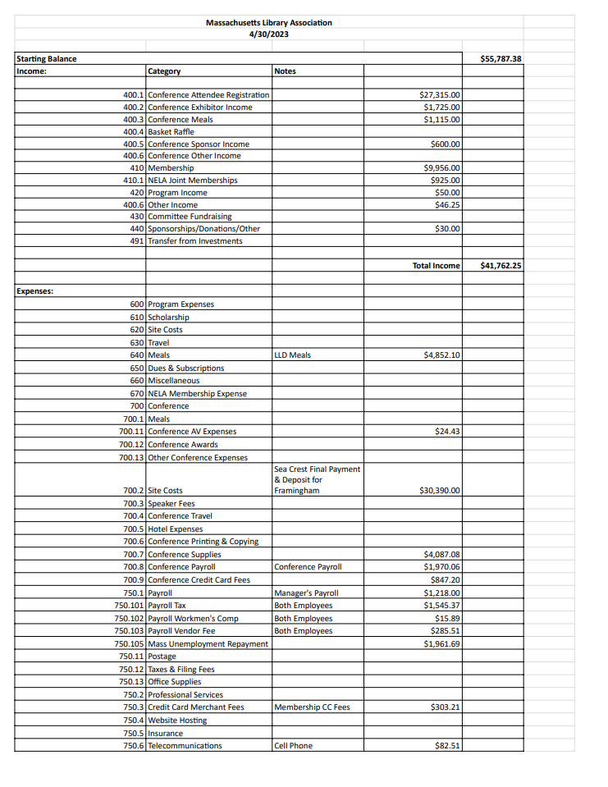

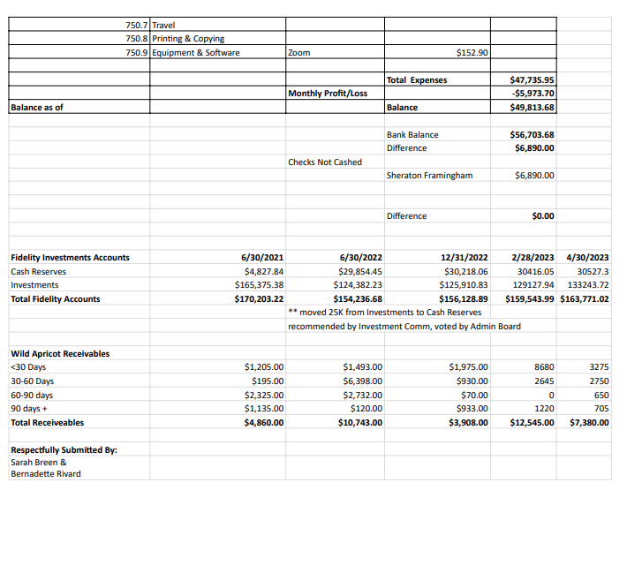

Youth Services Section

Mission:
The mission of this organization shall be to
- promote library service to youth
- promote the profession of youth librarianship
- further the awareness of youth within the profession
- further the awareness of youth within the community at large
- aid in implementing MLA state standards for the Massachusetts Library Services for Children and Young Adults

Meeting Information:
The 4th Tuesday of every other month at 2pm on Zoom

What we do:
During regular meetings, YSS focuses on how best we can serve the youth librarians of Massachusetts. We brainstorm continuing education opportunities, fundraising needs and provide a space for you librarians to ask questions and ask for advice.

We also have a Lunch and Learn meeting on our “off” months, where we invite Massachusetts librarians to share their expertise. This could also be used as an opportunity for those who might want to present at conference, but would like a little practice first.

