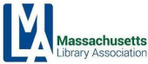

MLA Executive Committee Agenda
Friday, October 13, 10 – 12
Virtual Meeting via Zoom
Join Zoom Meeting https://us02web.zoom.us/j/82832523996
Meeting ID: 828 3252 3996

- Call to order
  - Vote to approve the minutes of the August 11, 2023 meeting
- President’s Report
- Treasurer’s Report (Sarah)
- Director of Operation’s Report (Michelle for Kristen)
- Conference Update (Conference Committee Co-Chairs)
- Committee Reports
- Update
  - MBLC
  - MLS
  - NELA
  - MSLA
  - Others
- New Business
A. Approval of Director of Operation’s salary
B. SLI / Massachusetts Library Association Partnership
- Old Business
- Adjournment
*Next meeting: Friday, December 8th (change date?)

President’s Executive Board Report — October 2023
Meetings attended:
- Growthzone Demo, August 21, virtual
- SLI/MLA Partnership Planning, September 6, virtual: This meeting was with the Sustainable Libraries Initiative to discuss a partnership with MLA and SLI.
- MBLC Board Meeting, September 7, virtual
- MLA Admin Board Meeting, September 8, virtual
- MLA Legislative Meeting, September 15, virtual
- MLA meeting with Kristen and Bernadette, September 27, virtual
- Star Chapter Demo, September 29, virtual
Upcoming Events:
- NELA, October 15-17, including Chapter Leader’s Forum, Sunday, October 15, Springfield, MA
- Western Massachusetts Library Advocates (WMLA) Virtual Annual Meeting, October 26
- MLS Annual Meeting, November 6th, Devens, MA
- ALA Chapter Advocacy Academy Workshop, December 8-10, Chicago, IL
Personnel/Chair Updates:
- Sara Slymon will be stepping up to Co-Chair the Leadership and Management Section.
- Kathy Lussier and Nora Blake will be co-chairing the Legislative Committee with Will Adamczyk
- The Admin Board met and discussed the Association Manager position that Kristen Collins has held, first as Interim Association Manager effective December 5, 2022 and then as the Association Manager as of July 1, 2023. It was decided to change the title to encompass her role, changing it to Director of Operations and raising her salary to 64,400.00. Kristen has not received a pay raise since 2018 and this would reflect the cost of living and the combination of her role as Conference Director and Association Manager. This salary raise must be approved by the Executive Board prior to moving forward.
Correspondence/Advocacy:
Per the request by the Collins Center for Public Management in the McCormack School at UMass Boston on behalf of the Healey Driscoll Administration, I worked with the Legislative and the IFSRC Committee to craft a letter detailing how the Commonwealth can partner with local communities and libraries. Be on the lookout for a fall listening tour by the Administration.
Respectfully submitted,
Michelle Filleul,
President

Treasurer’s Report
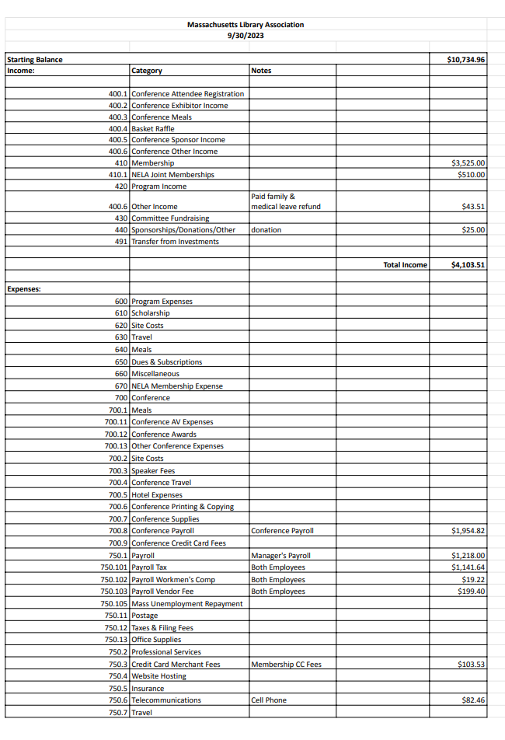

Treasurer’s Report – continued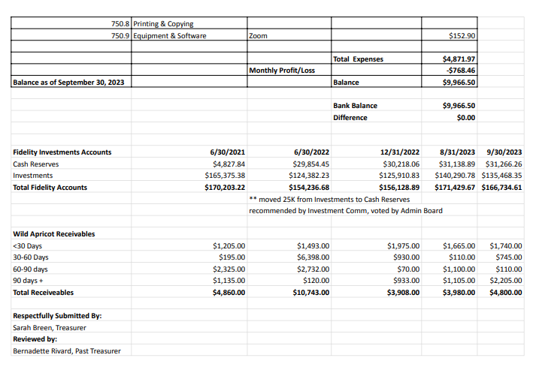

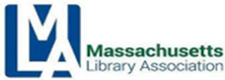

MBLC Director’s Report to MLA Executive Board
October 2023

Digital Equity Update: On 9/19 the MBLC held the “Introduction to E-rate” webinar. The session was led by Aleck Johnson of EdTech Strategies, the agency’s E-rate consultant. 41 attendees learned the basics of the E-rate program and what types of services qualify for what types of funding. The webinar featured a panel of librarians: Anna Fahey-Flynn from the Boston Public Library, Karen Wall from the Charleton Public Library, and Amy Rhilinger and Carrie Sylvia from the Attleboro Public Library. The panel talked about the positive impact that E-rate funds have had on their libraries, how they worked with municipal IT departments, how they manage the application process, and filtering requirements. A recording of the session is available on MBLC’s E-rate training page: https://mblc.state.ma.us/programs-and-support/e-rate/trainings.php

Electronic Database Update: On 9/20, Paul Kissman, Kate Butler, Rob Favini, and I and several members of the MLS staff attended a meeting with database vendor Gale at MLS.
Representatives from Gale reported on their latest product enhancements and Massachusetts usage data. Gale also used the meeting to gather feedback on how products and services can be improved to meet the specific needs of the Massachusetts library community. Gale databases include some of the most popular that are available to library users of all types.
COSLINE Annul Conference: On September 27-29th Maura Deedy and Rob Favini attended the annual Council of State Library Agencies in the Northeast (COSLINE) meeting in Philadelphia. This annual event brings together Library Development representatives from New England, New York, New Jersey, Delaware, Maryland, and West Virginia. This year’s meeting included an update from each state and informative sessions on teleservices in libraries, working with mental health gatekeepers in the community, artificial intelligence, training community catalysts, and intellectual freedom/book challenges.
MBLC Digitization Project: On September 12 the BPL Digitization team visited the MBLC office. We are looking for possible MBLC materials to digitize that may be of value to the library community. One potential project is the digitization of items from the agency’s clipping file. These files include 1-2 page field reports written by MBLC staff dating back to the early 20th century. This will be an ongoing project with updates to follow.
Evan Knight played a key role in organizing and promoting an emergency response training program that took place on September 25-26, 2023. The two-day workshop at the JFK Library was designed for a wide set of stakeholders who are responsible for cultural institutions and collections in the face of emergencies. The training was sponsored by the Foundation for Advancement in Conservation (FAIC), funded by a grant from the National Endowment for the
Humanities. A reporter from NPR attended the event and will be having a report on the radio soon.
On September 18-19th Maura Deedy, Mary Rose Quinn, and MBLC Data Analyst Aparna Ramachandran attended MLS’s two-day Research Institute for Public Libraries (RIPL)
workshop held in Devens. The workshop focused on the use of data in libraries and featured hands-on sessions covering:

MBLC Director’s Report to MLA Executive Board - continued

- Designing outcome-based evaluation of programs and services
- Assessing the needs of your community
- Techniques for tracking public library data and using these data for planning, management, and demonstrating the library’s worth
- Using data and stories to document the impact of your library
On September 12th Rob Favini spoke at the North Central Massachusetts Community Foundation on the Digital Equity landscape in Massachusetts and how public libraries are responding. Attendees included representatives from area United Way organizations, municipal planning officials, and members of regional planning authorities.

Mass. Public Library Construction Program (MPLCP) Update:
On September 22, the Sharon Public Library celebrated the groundbreaking for its new library of over 25,000 sf located about a quarter mile from the current library. This project is aided by a $7,485,943 grant from the MBLC and will feature expanded patron, staff, and programming spaces, a teen room, a media lab, improved telecommunications and HVAC systems, improved security and building access with full ADA compliance, a larger community room, quiet study spaces, and sufficient onsite parking.
The Sawyer Free Library in Gloucester held its groundbreaking for its renovation/addition project on September 29. The project, supported with a $9,030,047 MPLCP grant award, will centralize all the library facilities by renovating the current 1913 and 1976 buildings and constructing a new addition. The new library will have dedicated space for children and teens and restrooms on every level. It will be fully accessible to all, support more efficient and environmentally friendly heating and cooling systems, and provide a variety of spaces for studying, meeting, learning, creating, and performing.
On October 2, the Marlborough Public Library celebrated its grand opening after two years of construction, which was funded in part by a $10,186,626 grant from the MBLC. The original Carnegie building from 1904 has been renovated to preserve its historic character. The 1969 addition has been replaced with a larger, new structure that allows for full accessibility, 21stcentury technology and infrastructure, dedicated spaces for children and teens, quiet study rooms, meeting rooms, and expanded parking.
We have a new website showing the entire history of Massachusetts Public Library Construction Program (MPLCP), now live at https://mblcconstructionprogram.org/
The Communications Team worked with the construction consultants and Buyer Advertising to develop the new website https://mblcconstructionprogram.org/ . Based on the popular map poster, the site gives a snapshot of the program’s history and where projects are currently underway. Users can also search by municipality to find details of a community’s project. Lauren Stara wrote a blogpost highlighting the features.
MBLC Director’s Report to MLA Executive Board - continued
The team is also working with Western Massachusetts Library Advocates on a road trip site that will launch mid-October. This is the third network/region that the team has partnered with and has the goal of highlighting resource sharing across the state. The SAILS road trip happened during spring break 2023. OCLN launched their successful library crawl in the summer and they’re putting together a program for the MLA Conference highlighting their site and working with the MBLC.
A summer wrap up video that highlights the library visits with Blades is available. Thank you to Commissioners Cluggish, Comeau, Vilas Novas, and Chair Conrad for participating.
Libraries are currently able to order bookmarks that highlight the statewide databases. The team worked with the statewide PR Committee and Tressa Santillo from the Massachusetts Library System to divide the databases by age so that anyone doing research could just scan the QR code and be taken to the most relevant resources for them.
The team is also working with Kate Butler and Paul Kissman to finish the consumer portal. The portal’s focus is to bring new users to libraries both online and in person. Based on a PR Committee survey of the users and non-users done in preparation for the portal redesign, the portal highlights the services that matter most to new and returning users including eBooks and internet access. New features also include a statewide Library of Things and a new statewide events calendar.
The Read-In to celebrate banned books week included 75 registered libraries. The communications team worked with members of the Joint Task Force for Intellectual Freedom to develop the program materials and feature the Read-In on the consumer portal. NBC Boston did a nice segment on the Read-Ins: Have a look.
Staff news:
Evan Knight, our Preservation Specialist, has let us know that he will be leaving the MBLC on October 13 to return to graduate school. In addition, two of our five veteran staff members who have announced their retirements will be leaving us in October. Paul Kissman and Lauren Stara’s last day with us will be Friday, October 27.
Please join me in thanking them all for their dedicated service to the MBLC and to the Commonwealth’s libraries and best wishes to Evan, Paul, and Lauren for the future!

MLS Update
October 2023
Strategic Initiative 1 MLS ensures its services are sustainable, prioritize member needs, and equitably serve all member types

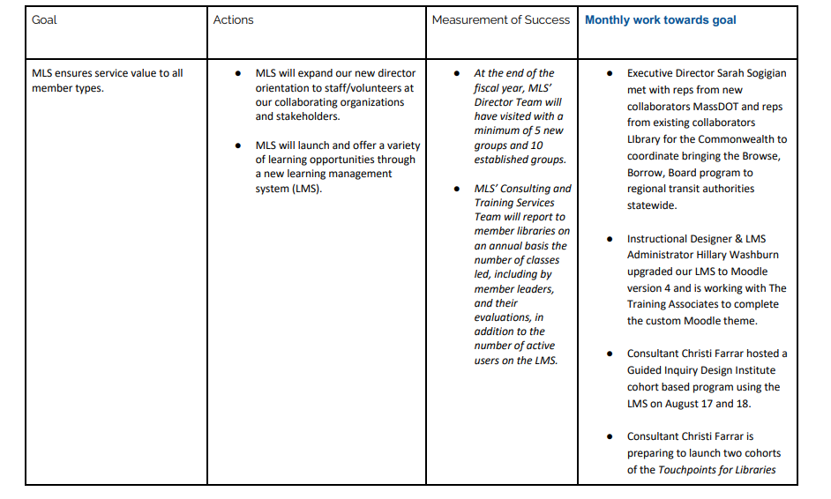

MLS Update - continued

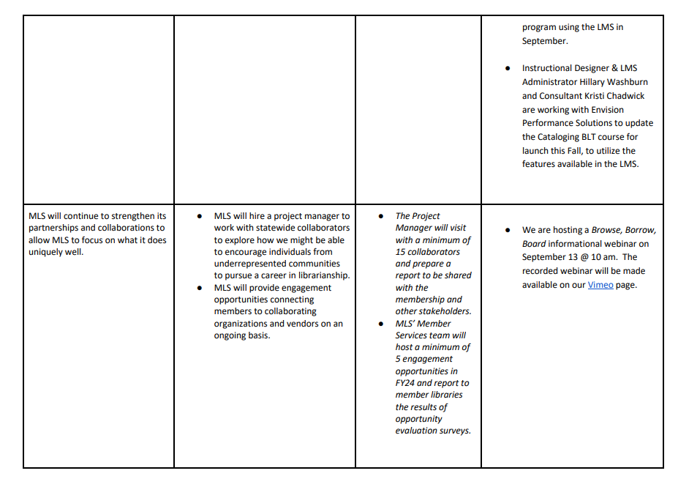

MLS Update - continued

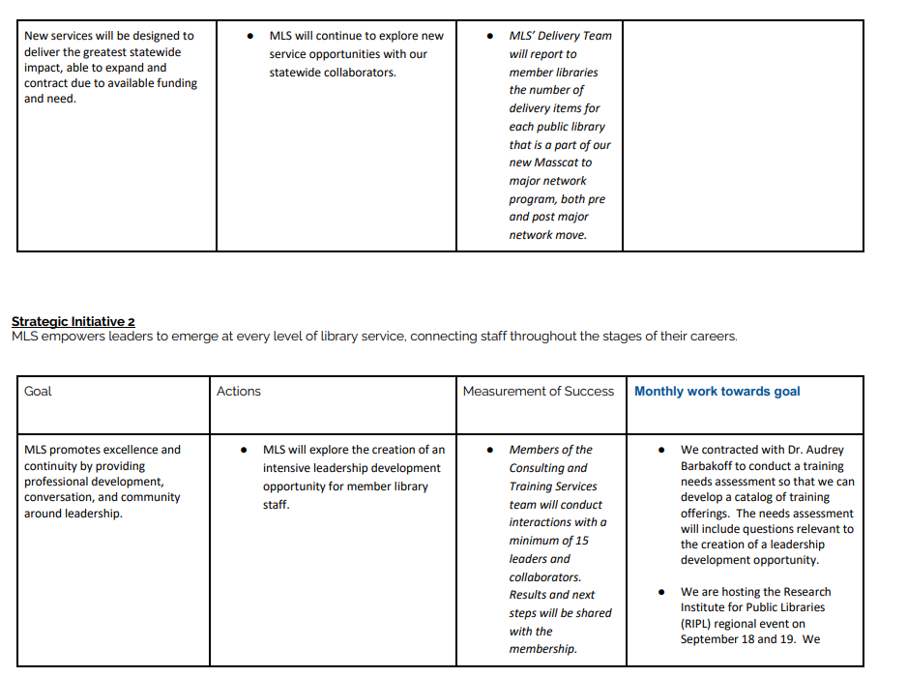

MLS Update - continued

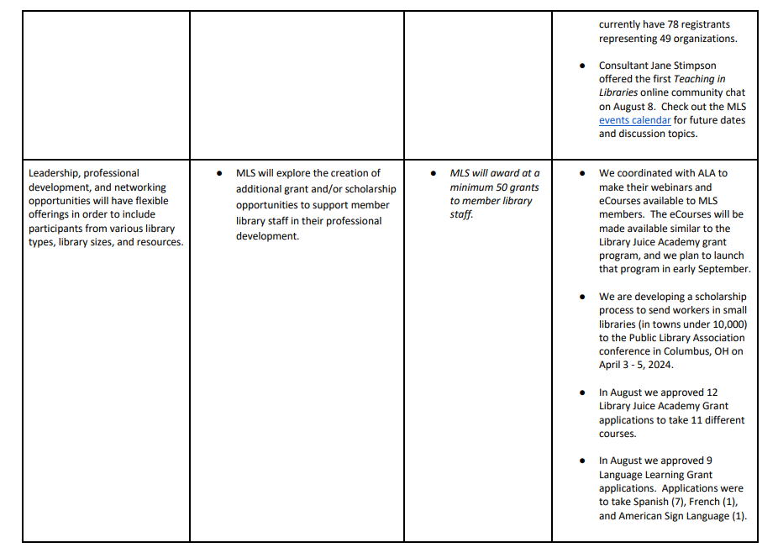
Strategic Initiative 3
MLS will take the lead in facilitating important conversations, and support member-facing initiatives focused on DEI: diversity, equity, inclusion, accessibility and social justice
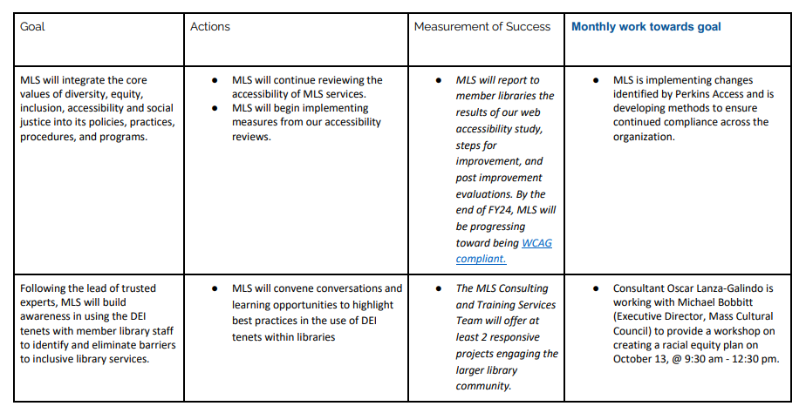

MLS Update - continued

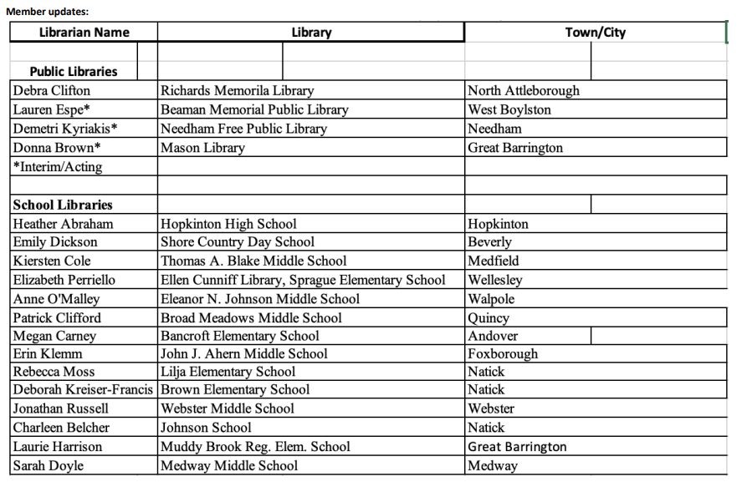

MLA PPS (Program Planners Section)
Report For October 13 MLA Executive Board Meeting

I. Membership Update
- 130 section members
- trying to recruit 60 prospective members who have attended our section’s meetings/webinars in the past, but aren’t MLA members yet.

II. Officers Update
- Katie Carlson (Beverly Library) is our section’s new Treasurer.
- Darshana Merchant (Norwood Library) is our section’s new Vice Chair.
- All officer spots have now been filled.

III. October Webinar Schedule
- Tues., 10/10, 2pm: Applying For Local Cultural Council Grants
  - 40 registered & 20 attended; positive feedback; recording sent to all section members
- Tues., 10/17, 2pm: Art History Presenter Showcase
- Tues., 10/24, 2pm: Big Programming Ideas for Small Budgets
- Tues., 10/31, 2pm: Advancing Small Businesses & Entrepreneurship In Libraries
- November webinars will be scheduled soon. Webinars will remain on Tuesdays at 2pm. These are open to all MLA members.

IV. October Meeting Schedule
- Tues., 10/10, 3pm: MLA PPS Officers Meeting
- Fri., 10/13, 10am: MLA Executive Board Meeting,
- Tues., 10/17, 3pm: MLA PPS Adult Programming Subcommittee Meeting
- Recently surveyed members on preferred meeting times for full section meetings.
- Next full section meeting will likely be on Tues., 11/14 at 3pm, but that is tentative.

V. Conference Proposals The Program Planners Section Would Like To Sponsor
- How To Host A Successful Author Program (Meena Jain)
- How To Run A Successful Adult Craft Program (Gabi Toth & Bri Ozanne)
- OCLN Library Crawl (Zoe Rath & Brian DeFelice)
- Brewfest (Haley Lawrence)
- Programming For 20’s & 30’s (Haley Lawrence)
- Service To The Incarcerated (Chelsea Jordan Makely & Sarah Hertel-Fernandez)
- We declined to sponsor a Repair Clinic presentation, as we just sponsored one last year.
- Most of these proposals have already been submitted. Any stragglers will be submitted by 10/13.

MLA PPS (Program Planners Section) - continued

VI. Action Items
- Submitting A FY25 Proposed Budget to MLA by 10/31
- Creating A 2-Year (18-Month) Action Plan by 12/31
- Checking In On Status Of Mentorship Program with MLA (ongoing)
- Checking In On Status Of Website Makeover with MLA (ongoing)
- Robert recently learned on how to send email newsletters (thank you Kristen). Robert re-learned how to post events on EventKeeper. Robert filled in the membership spreadsheet. Robert next needs to update the section’s webpage.

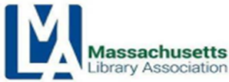

Intellectual Freedom/Social Responsibility Committee
MLA Executive Board Report — October 2023
Past Activities:
- Sep 14, 2023 meeting at the Wellesley Free Library
- Finalizing conference proposals
- Working with MBLC, libraries throughout the state, and media to launch Read-Ins and other events to draw attention to censorship during Banned Book Week- 77 libraries throughout the Commonwealth participated in our polite protests. Media coverage was robust, including television, radio, and newspapers.
- Committee member Martin Garnar presented on censorship at Tufts Osher Lifelong Learning Institute, the Central Mass Library Advocates in Shrewsbury, and as a panelist at the Defending Democracy event in Lynn
- Co-Chair Andrea Fiorillo provided a staff training on censorship and harassment at Ashland Public Library
- Co-Chair Andrea Fiorillo introduced and presented with lawyer and librarian Jocelyn Kennedy on past and present censorship in the U.S. The webinar was open to all MA libraries and library staff and hosted by IF/SR Committee members from Reading, Wellesley, Nahant, Norwood, and Lynnfield
- Co-Chair Susan Caulfield gave a public presentation on intellectual freedom sponsored by The League of Women’s Voters of Marblehead
- Committee member/MBLC Liaison Maura Deedy attended a meeting with Congresswoman Ayanna Pressley at Turner Free Library in Randolph. She hosted an informal meeting with librarians, trustees, PTO members, a town manager, select board members to discuss the state of book challenges and its impact on queer and BIPOC students. Congresswoman Pressley opened the meeting with the most moving remarks on how a book saved her life. Maura shared about the current laws requiring collection development policies and protections for public library workers, and the gap for school librarians
- Congresswoman Pressley asked thoughtful questions about the impact of book challenges on the recruitment and retention of library workers
- MLA President Michelle Filleul and Co-Chair Andrea Fiorillo met with the founders of the Sustainable Library Initiative to explore a partnership which will give MLA member libraries a discount for sustainability certification and free on demand professional development

Intellectual Freedom/Social Responsibility Committee - continued
Upcoming and Ongoing Work:
- MLA Conference 2024
- Hamilton-Wenham Human Rights Coalition-Reading Dangerously Panel
- Staff training for the Goodnow Library
- Consulting on cases of challenges to programs and collections
- Speaking with the media
- Next meeting TBD

Respectfully submitted,
Susan Caulfield and Andrea Fiorillo Co-Chairs, IF/SRC

Interim Association Manager Monthly Activity Report
Name: Kristen Collins
Date: October, 2023

Member Relations | - Managed incoming emails/inquiries/phone calls  - Renewed some people’s memberships
Technical | - Scheduled and hosted a demo with Growthzone and Star Chapter with admin board members
External Relations | - Prepared NELA report and sent to NELA rep  - Created new members via ALA  - Followed up several times with both the NELA liaison (Megan Bishop) and NELA president as we have not received invoices since April for our NELA partnership.  - I send them a report of all financial transactions occurring in the previous month that had a NELA membership transaction  - From that report they calculate a fee and send us an invoice to pay  - We have not received one since April (so May, June, July, August invoices from NELA have not been received or paid)  - MLA Treasurer has been notified
Conference Management | - Launched exhibitor, sponsor and ad registration (4 exhibitors registered as of 10/4)  - Created exhibitor/sponsorship prospectus  - Met with insurance company to confirm if we should be getting certificates of liability insurance from vendors and they said yes  - Received approval to increase registration rates and exhibitor rates  - Call for proposals in motion with 35 received to date
Finance
Next steps | Conference:  - Source 2025 program  - Schedule demo meeting with Personify (MemberClicks)  - Follow up with other chapters that use Star Chapter

MLA Legislative Committee Report
MLA Legislative Committee Report
October 2023

The Legislative Committee held its first meeting of the fiscal year on September 15, 2023. We expect a very busy legislative season with several pieces of legislation affecting libraries filed at the statehouse. With new volunteers on the committee, we asked for volunteers to participate in our subcommittees: book challenges, conference, eBook bill, legislative date, and legislative advocacy/collaboration. Nora Blake and Kathy Lussier are joining Will Adamczyk to co-chair the committee this year.

eBook Legislation
Will Adamczyk and Kathy Lussier met with Rep. Ruth Balser and Rep. Mindy Domb, Chair of the Joint Committee on Tourism, Arts and Cultural Development, to discuss H.3239, an act empowering library access to electronic books and digital audiobooks. The meeting was very positive and Chair Domb had several suggestions for moving forward:
- Pulling together numbers showing the amount of money spent in this state on digital content. The Legislative Committee has since compiled this information.
- Highlighting the benefit these collections have for different populations, particularly people with visual disabilities, and ensuring these voices are reflected when the committee holds its hearing.
- Making sure a large contingent of librarians and end users show up at the hearing. There’s a possibility the publishers will have a large turnout, and we need to counter those numbers.
- Reaching out to the creative community, especially authors.One of the arguments publishers have been making is that this legislation will negatively impact authors.
We have heard that the hearing for this legislation is tentatively scheduled for October 30, 2023. The legislative committee is currently lining up people to submit oral and written testimony for the bill.

Legislation Related to Book Challenges
Four separate pieces of legislation have been filed to support libraries in the face of the recent increase in book challenges. Three of those pieces of legislation have been referred to the Joint Committee on Tourism, Arts, and Cultural Development, and it is quite possible that hearings for those bills will be scheduled on the same day as the eBook bill. The other bill, filed by Senator Julian Cyr, has been referred to the Committee on Education because it also addresses challenges in school libraries. The Legislative Committee is reaching out to the Intellectual Freedom Committee to coordinate on this legislation.

MLA Legislative Committee Report - continued

EveryLibrary

The legislative advocacy/collaboration subcommittee has been meeting with John Chrastka of EveryLibrary to help us strengthen our legislative activities. In our first two meetings, we focused on building a better relationship with the library legislative caucus and planning our advocacy around the eBook legislation. As a follow-up action to our second meeting, we have been working on identifying people to testify at the upcoming hearing. We are trying to use people who can help build a strong narrative of support.

During our next meeting (10/10), we will discuss coalition building and review other bills that could benefit library workers/users and our final meeting (10/17) will be devoted to the book challenge bills. As a follow-up action to our first meeting, the MLA co-chairs have scheduled a meeting with Representatives Higgins and Murray from the library caucus to discuss how MLA and MSLA can best work with the caucus.

Respectfully submitted,

Will Adamczyk, Kathy Lussier, Nora Blake
Cochairs, MLA Legislative Committee

Paralibrarian Section
October 2023

Our last meeting was held virtually on September 12, 2023. The following was discussed:

MLA Conference:
- Brainstormed program ideas for the 2024 conference. Three programs (including awards/annual meeting) were submitted.
- Our annual meeting and presentations for PARA certifications and Awards (Outstanding Paralibrarian of the Year and Advocate of the year) will be announced at this annual meeting.

PARA Certification:
- Gerry met with Kristen, the MLA interim manager, and set up the registration for the PARA Certification to apply and pay online.

2023 – 2024 Next Meeting Dates:
- 11/14/23, 1/9/24, 3/12/24,
- 4/9/24 (5/6/24 5/7/24 Conference) 6/11/24

Respectfully submitted,

Anna McGrath
Chair Paralibrarian Section

Youth Services Section Report
October 6, 2023

YSS held its last meeting on September 26, 2023. The YSS board agreed to continue the section’s virtual Lunch ‘n Learn series, a bi-monthly program featuring short presentations from youth services librarians on relevant topics in the field. The first Lunch ‘n’ Learn will be held on Tuesday, October 24 at 2 PM and will focus on programming for neurodiverse youth.

The YSS Vice Chair position is currently unoccupied, as well as several Members-At-Large positions. Kate Tigue will put out a general call for candidates in October through MASSYAC and other channels. Once a list of candidates has been compiled, the section will hold an election for members in the late fall.

Christi Farrar from MLS proposed a collaboration with YSS on updating the Standards for Public Library Service to Children in Massachusetts, a document created by YSS in 2012. This document has not been updated since its original publication. Christi proposed that YSS members review its contents and use them to create a more current, succinct version. Once these standards are updated, Christi will use them as the foundation of an asynchronous basic practices course for youth services staff to be hosted on MLS’s online learning platform. Kate and Christi have agreed to table this project until Spring 2024 when both parties have more bandwidth and all YSS vacancies have been filled.

Aimee Villet, former MA teen librarian and current youth services director at Glen Carbon Library in Illinois, reached out to YSS to find youth services librarians to contribute to the iREAD Summer Reading Resource Guide for children and teens. Kate Tigue will pass along this opportunity to all MA youth services librarians via MASSYAC.

The next YSS meeting will occur on November 28, 2023

Respectfully submitted,

Kate Tigue
Chair

Jordan Miller Committee Report
October 11 2023

In this year’s grant cycle the Jordan Miller committee will give preference to libraries inside Massachusetts.

We will send out a call for applications on November 1.
Applications will be due by November 22, and we will
announce the winner on December 1.

Respectfully submitted,

Pam McCuen and Amy Dorsheimer
Jordan Miller Committee Co-Chairs

